| **Sr.No.** | **Name of document** |
| --- | --- |
| 1 | Introduction |
| Objectives of the feedback |
| Process of feedback |
| Stakeholders of the Institution |
| Methods of collection & analysis of feedback |
| 2 | Sample Student Feedback form |
| Analysis of Student Feedback form |
| Sample Alumni Feedback form |
| Analysis of Alumni Feedback form |
| Sample Faculty Feedback form |
| Analysis of Faculty Feedback form |
| Sample Employer Feedback form |
| Analysis of Employer Feedback form |
| 3 | Action taken report of the Institution |

**Introduction:**

The Institution collects the feedback from various stakeholders. The main aim behind this feedback process is to know whether the syllabus of the courses in the Institution are as per the recent market requirements.

**Objectives of the feedback:**

1. To understand the views of faculties regarding the upgradation of the curriculum.
2. To help the Institution to know whether the courses provide employability to the students.
3. To understand the expectations of the industry and cater the needs by creating competencies that are required for industry through academic learning.
4. To understand the views of alumni regarding the upgradation of the curriculum.

**Process of Feedback:**



**Stakeholders of the Institution:**



**Methods of collection & analysis of feedback:**

1. **Students**: The student feedback is collected based on the curriculum through google form. Analysis of the feedback is done by Principal madam.
2. **Faculty/Teachers:**The faculty feedback is collected based on the syllabus and its transaction through google form. Analysis of the feedback is done by Principal madam.
3. **Alumni**: The alumni feedback is collected based on the curriculum through google form. Analysis of the feedback is done by Principal madam.
4. **Employers:**  The Employers feedback is collected based on the syllabus and its transaction through google form. Analysis of the feedback is done by Principal madam.

**Sample Student Feedback form**

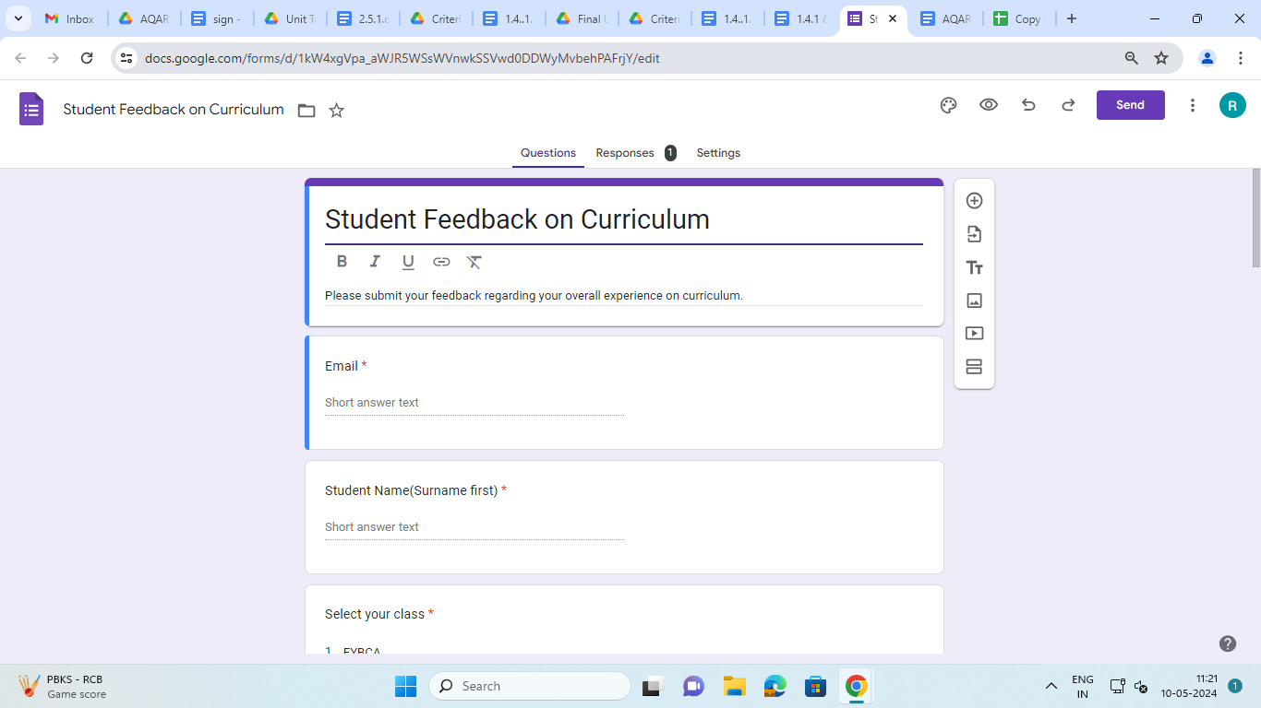

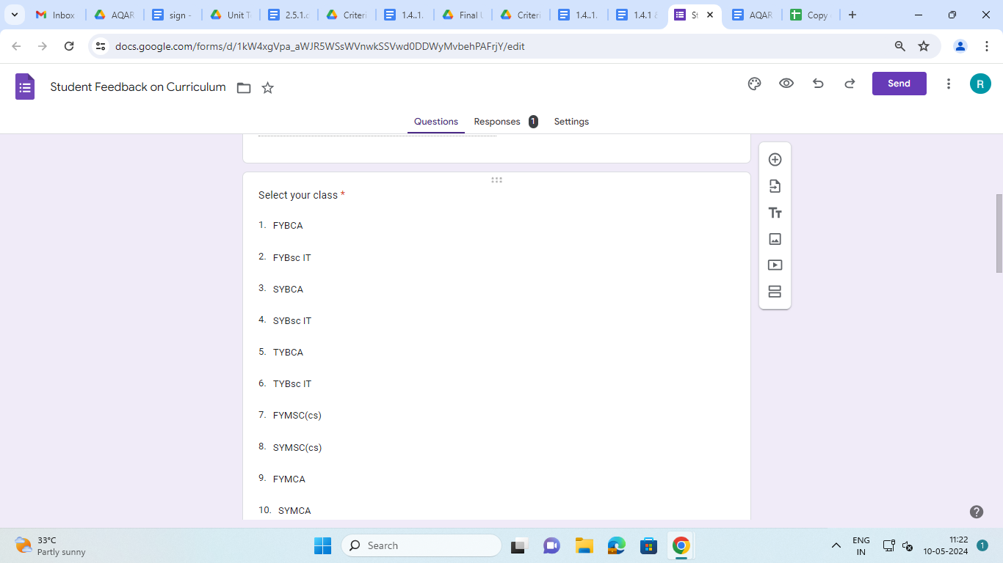

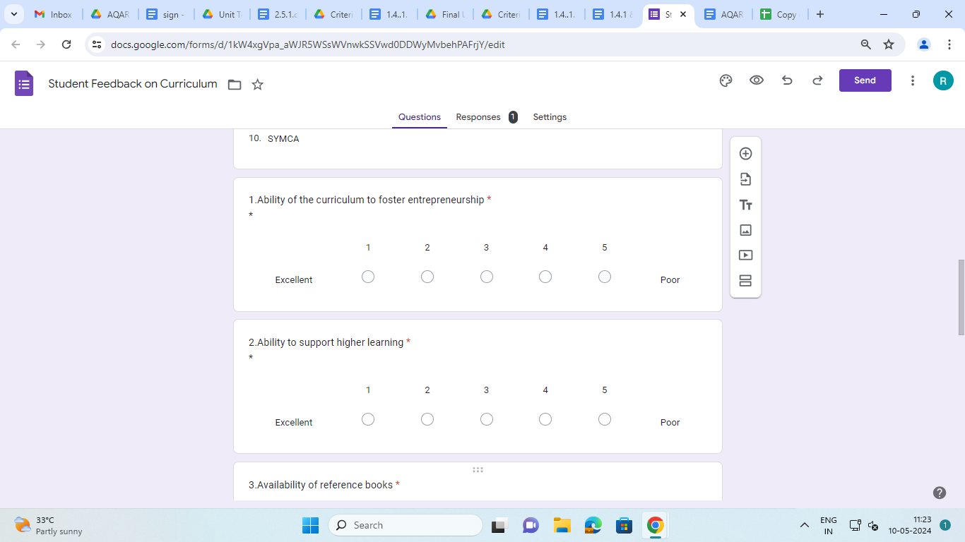

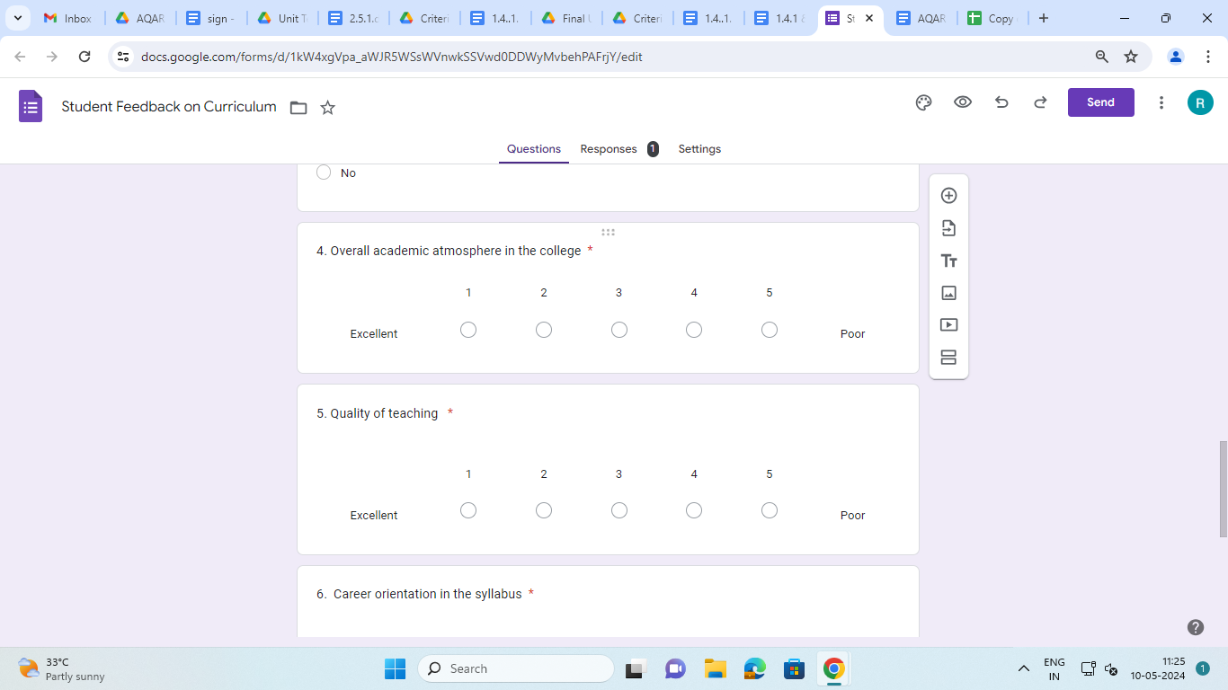

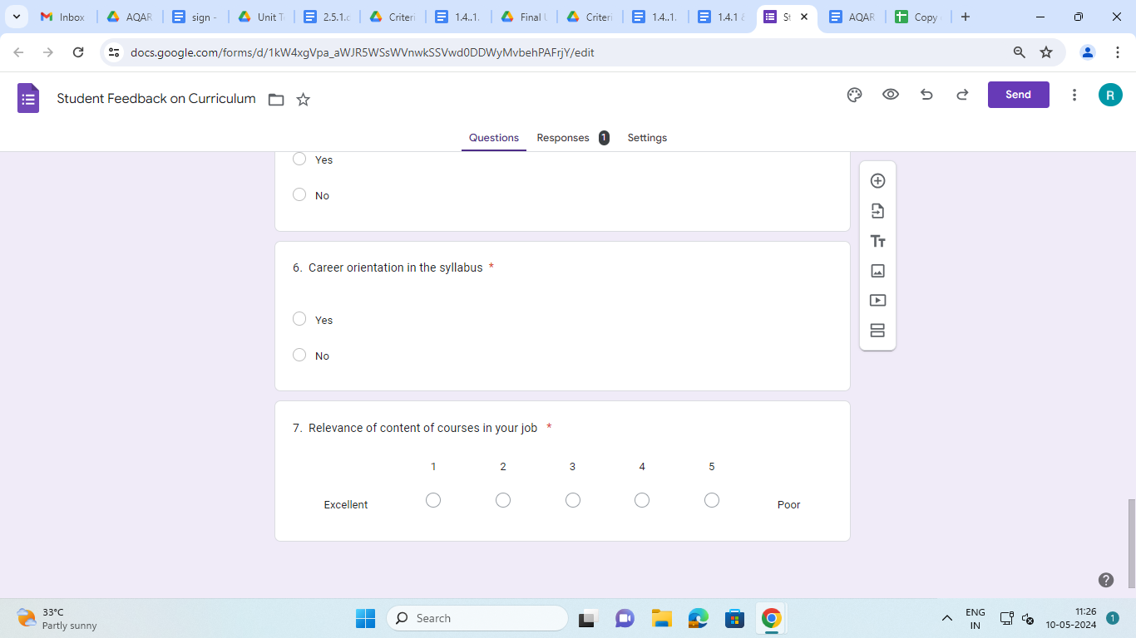

**Analysis of Student Feedback form**

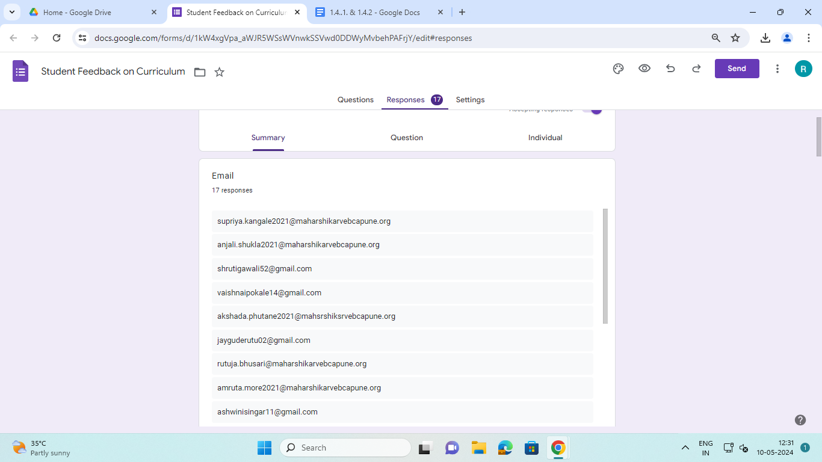

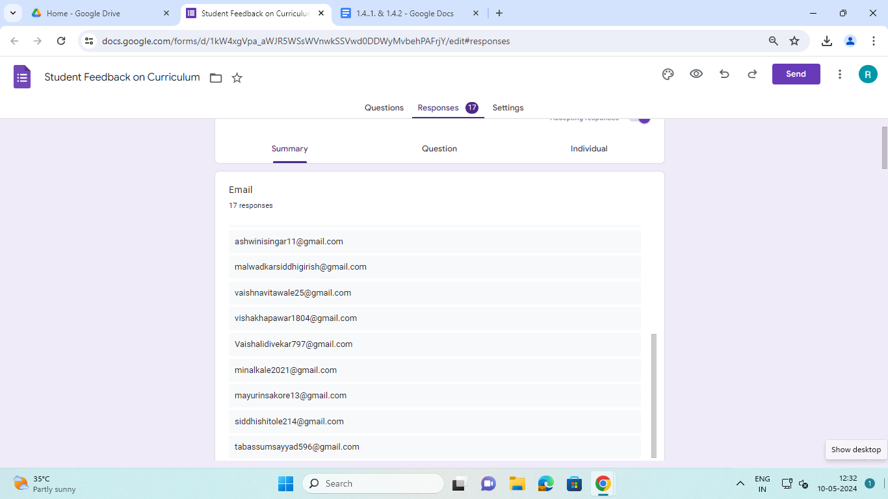

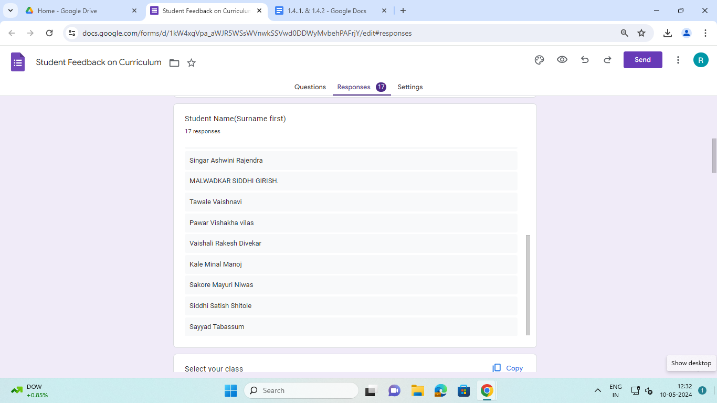

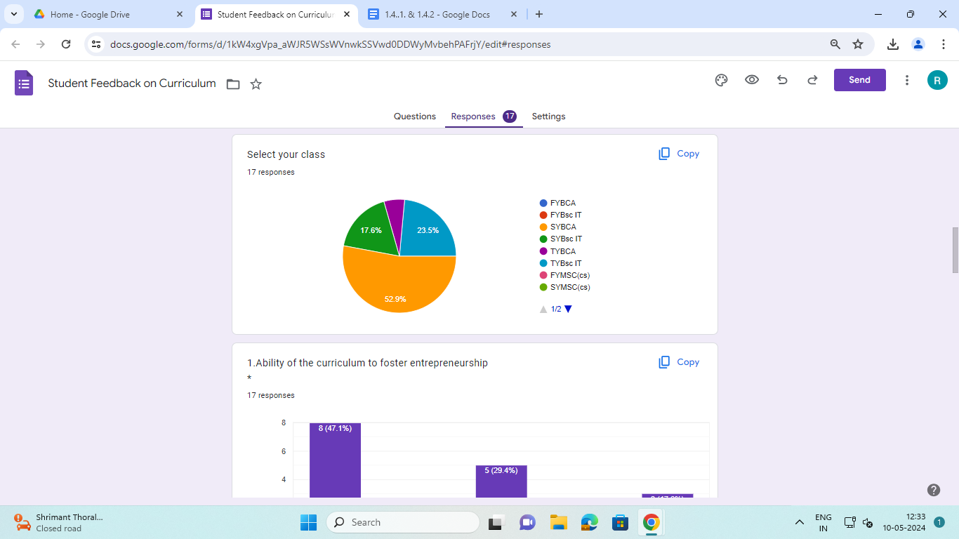

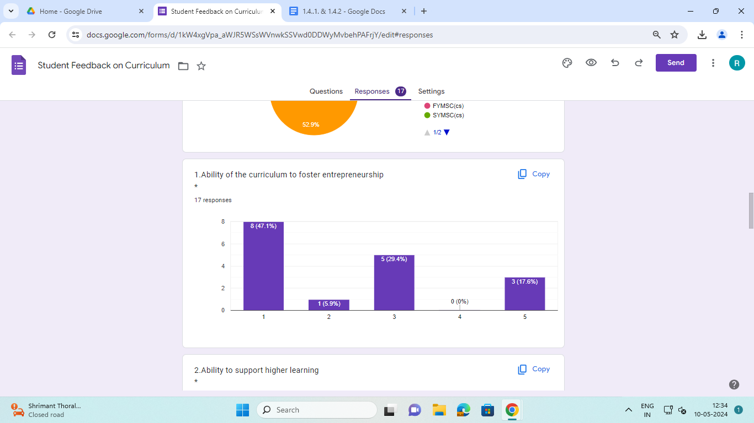

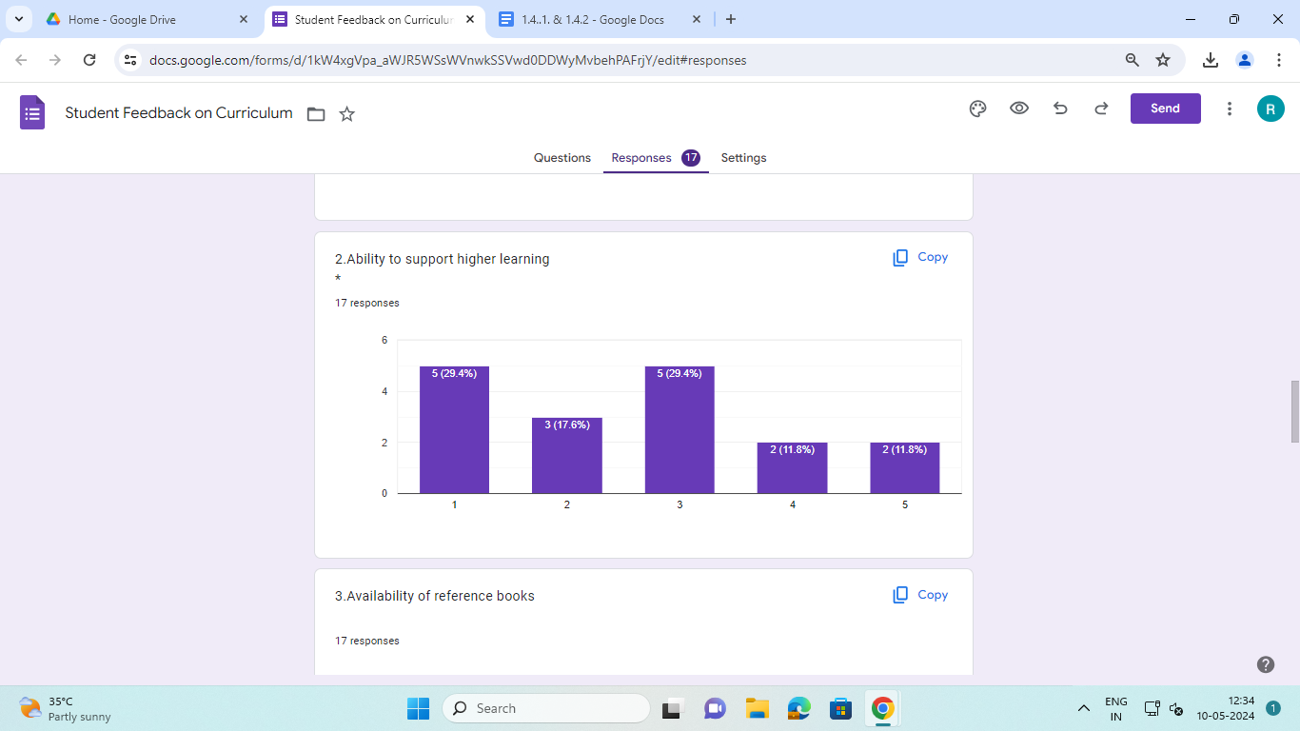

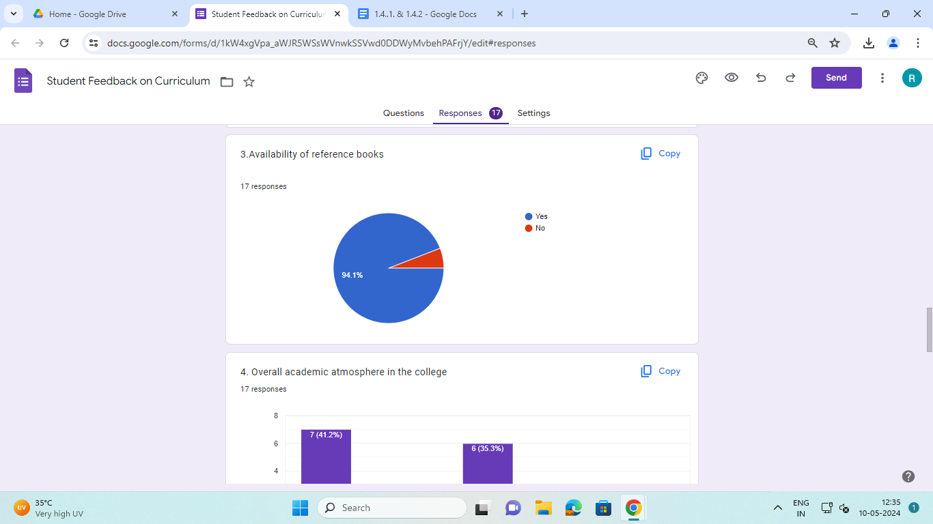

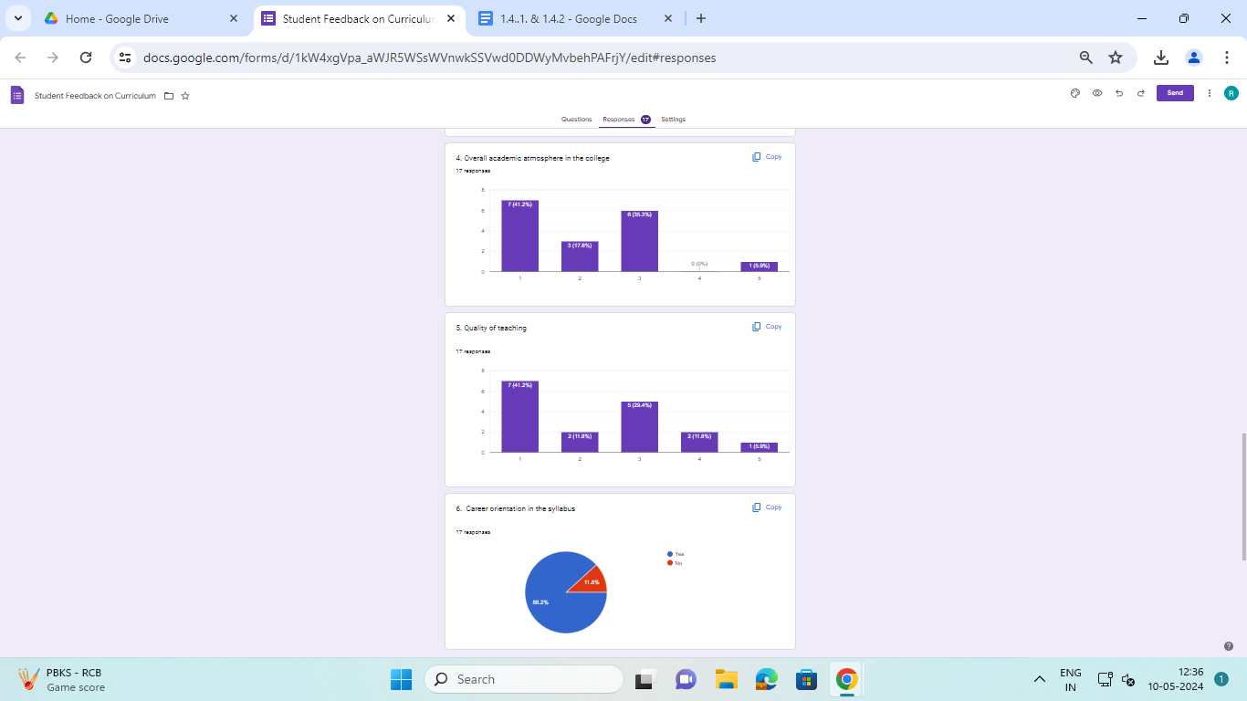

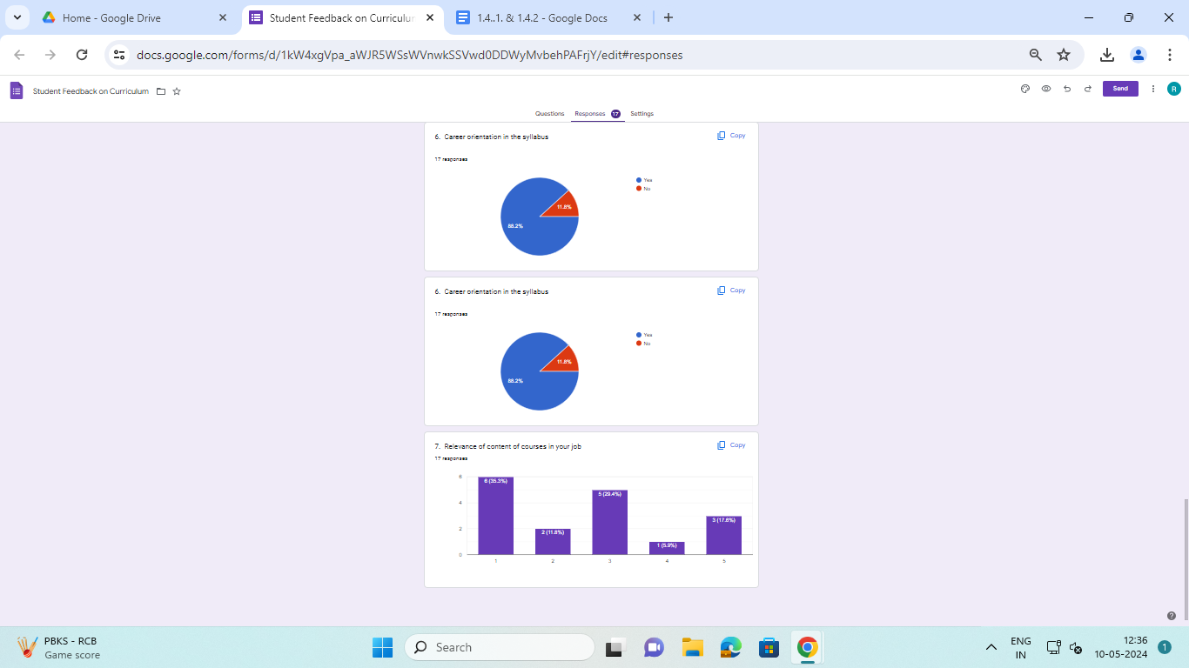

**Sample Employer Feedback form**

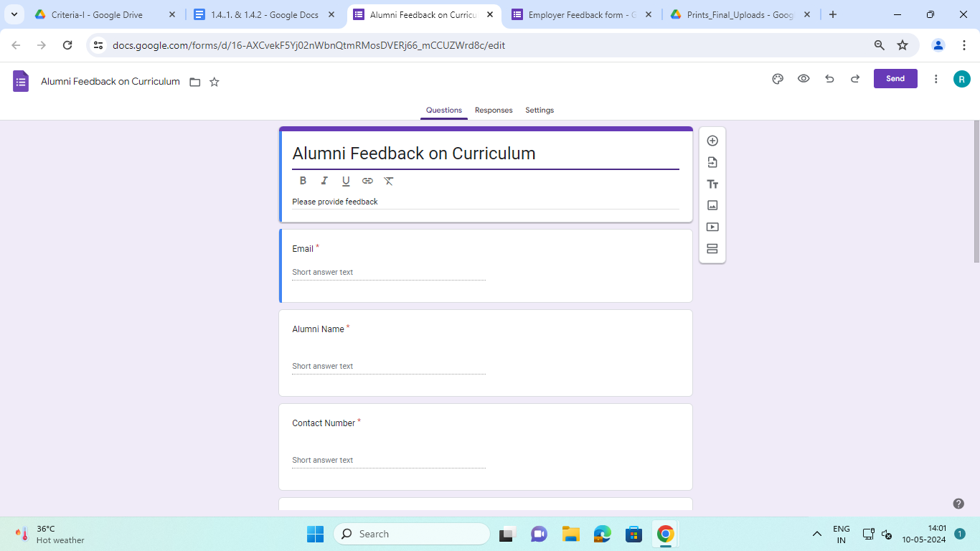

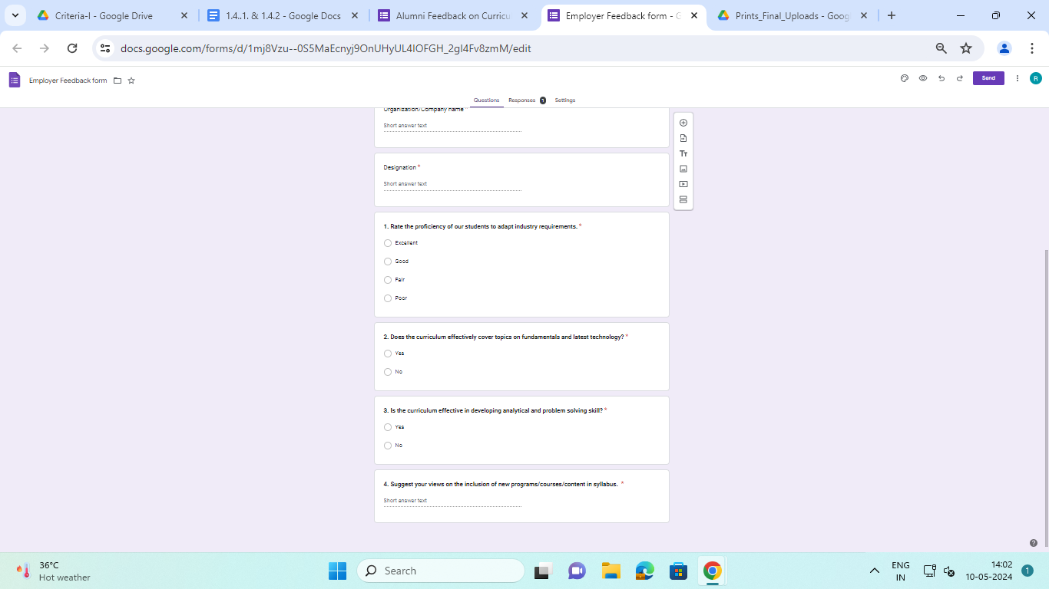

**Analysis of Employer Feedback form**

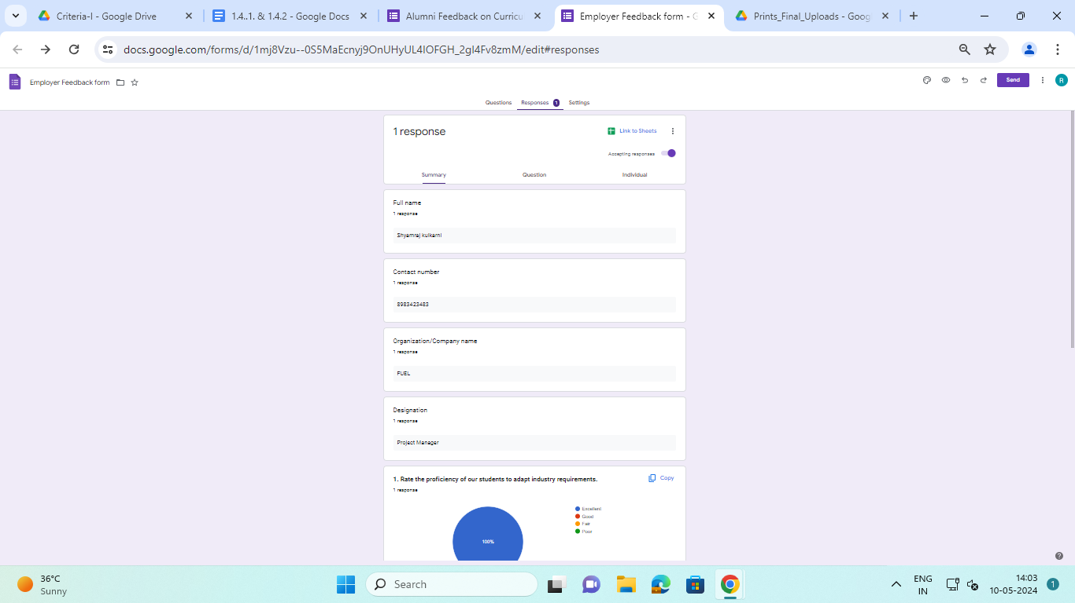

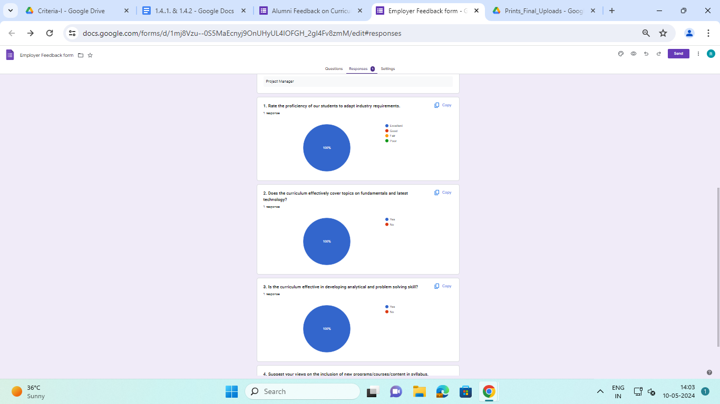

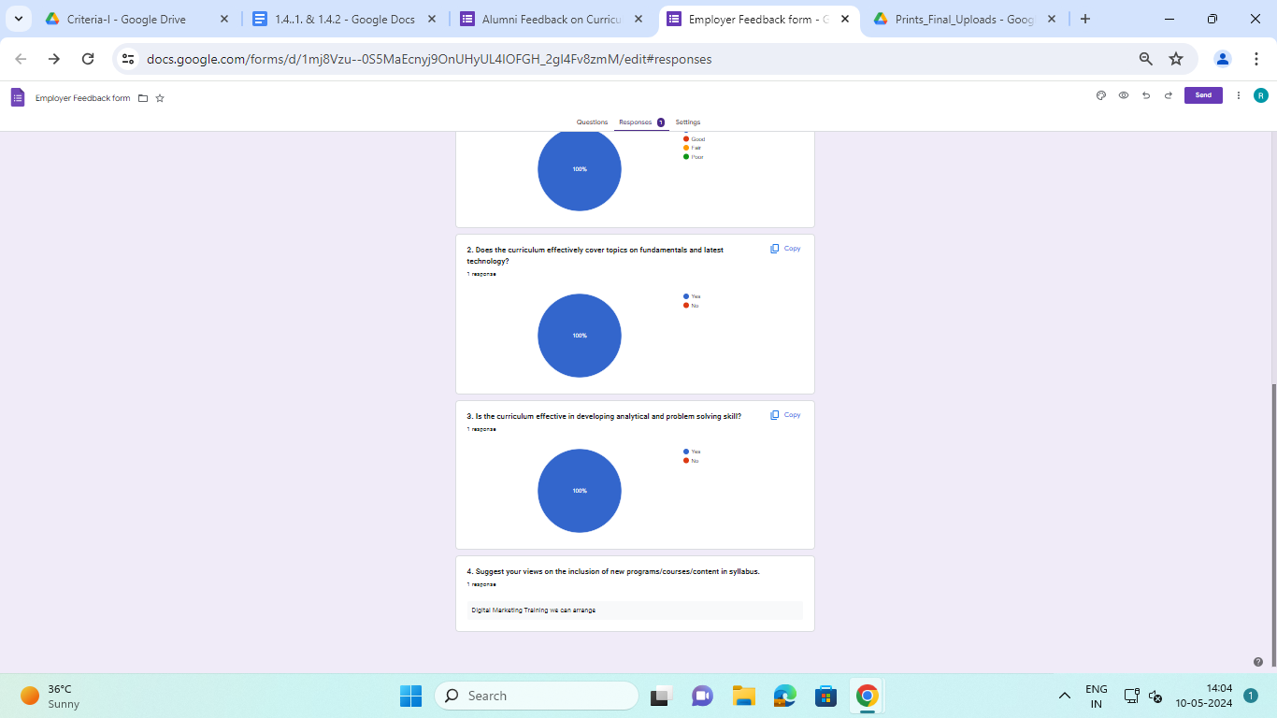

**Action taken report of the Institution**

| **Feedback** | **Action taken** |
| --- | --- |
| Student | Based on the feedback received from students the Institution had organized workshops and training sessions for the students. |
| Faculty/Teachers | Based on the feedback received from various faculty members, training sessions and workshops were organized by the Institution. |
| Alumni | Based on the feedback received from alumni guidance sessions and lectures were organized by the Institution. |
| Employers | Based on the feedback/suggestions received from the industry experts the Institution has incorporated the changes in the curriculum. |